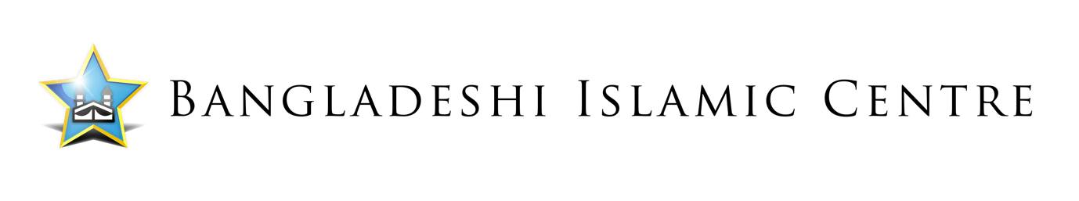
Vacancy

Supporting Women from Isolation to Empowerment (SWFITE)

JOB TITLE: Part Time Women’s Development Worker

RESPONSIBLE TO: CEO

ACCOUNTABLE TO: Management Committee

PURPOSE OF JOB: To listen and respond to the needs of Asian Women within the local community, offering advice, support and services to enable them to be empowered individuals.

SALARY: £16,900 per annum

HOURS OF HOURS: 25 hours per week

CONTRACT: 24 months fixed term

DISCLOSURE: The successful candidate will not be confirmed into post until (DBS) has been carried out and the
results are satisfactory.

LOCATION: Sandwell

DUTIES & RESPONSIBILITIES:

- Recruit, train and support women from the community to become volunteers.
- Run effective sessions to improve women’s health and wellbeing.
- Help local women gain education and skills to further their prospects of bettering their opportunities in life.
- Deliver Advice and guidance to clients on a range of different issues especially welfare rights and financial entitlements.
- Develop links and relationships with a wide range of partners from across public, private and third sector organisations, harnessing their commitment and support to generate referrals into the service.
- Communicate effectively with a wide range of people to build and sustain effective and positive relationships across public, private, community and voluntary sectors, to develop relationships, and joint working in support of the project.
- To establish effective partnerships to support the work of the (SWFITE) project.
- To plan deliver and manage activities in line with the (SWFITE) project objectives.
- To carry out data collection and evaluation of the (SWFITE) project through user feedback, individual case studies and project impact assessments.
- Consult with all sections of the local community to gain an understanding of the problems and issues faced by women, in particular Asian women and work towards finding effective solutions.
- Delivering sessions and initiatives to tackle disadvantages faced by women.
- To produce yearly progress report to the TNLCF and quarterly reports for the management and steering committees taking into account feedback provided by them.
- To align all work delivered on the project to the needs of the client group and the organisation’s ethos.
- To enhance Asian Women’s involvement in their local community and services.
- To maintain and develop partnership arrangements with, voluntary, community organisations, the local Authority and education and training providers
- To participate in individual and team development training.
- To carry out any reasonable duty when required by the CEO.
- To report in meetings to the CEO & Management Committee.
- To ensure that all policies and procedures are adhered to, including Health & Safety, GDPR, Safeguarding Vulnerable Adults and Child Protection Policies.

Person Specification:

The right candidate for this role will have knowledge and experience of working within a community setting, managing and delivering projects. The Women’s Development Worker will be able to demonstrate the commitment and cultural sensitivity it takes to work with disadvantaged individuals from ethnically diverse communities.

Essential Experience, Knowledge & Skills:

- Experience of working with people in a multi-cultural society.
- Experience of developing and running activities in a community setting.
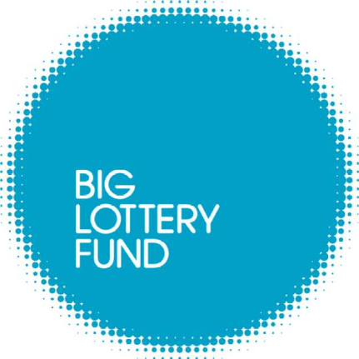
- At least three years’ experience working within a community organisation/setting.
- Ability to organise, lead and motivate team members and volunteers.
- Ability to constantly improve own practice/knowledge through self-evaluation and learning from others.
- Ability to relate well to client group and other professionals.
- Ability to demonstrate and promote good practice in line with the ethos of the organisation.
- Ability to monitor, evaluate and report on projects progress.
- Experience of supervising the work of individuals or teams.
- Ability to demonstrate experience relevant to the role.
- Good communication skills, both written and verbal including the ability to present information clearly.
- Demonstrate experience of managing a case load.
- Ability to work independently and as part of a team.
- Experience planning and delivering training and educational workshops.
- Understanding of, and commitment to, equality, diversity, and inclusion.
- Managing sensitive information and following GDPR procedures.
- GCSE English Language and Mathematics (Grades A-C).
- NVQ4 or NVQ3 plus additional training to diploma level equivalent, or equivalent through short courses.

Desirable Experience, Knowledge & Skills:

- Fluent in Bengali, Urdu or other Asian community languages.
- At least two years of experience directly working with Asian women.
- Driving licence and access to own car.
- Knowledge of community and women development issues.
- Demonstrate enthusiasm.

Closing date: Tuesday 27th August 2024 – 4.30pm

This vacancy is Funded by the National Lottery Community Fund

